**ABOUT US:-**

**1- Who are we?**

-CIVI (the first four letters of the word civilization) is an independent project that aims to build more civilised community that is aware of its surroundings, have the ability to enlighten others and works on the future generations’ knowledge. CIVI is subdivided into two main projects which are AMAL and CULTIVO.

AMAL, a word with multiple meanings in different languages, in Bangladesh’s language “Amal” means deeds and in Indonesia’s language it means good deeds, while in Arab’s language it means hope. It is an online platform to collect donations for several charity projects.

CULTIVO, is originated and used in the Spanish Language with the meaning of cultivation, It is an educational and awareness project that aims to cultivate the society through all the possible and accessible media and channels.

Generally, the objectives of CIVI are obtained through these two subprojects. The projects will be conducted independently with the help of our teams in different countries.

Moreover, we are a group made of working employees, fresh graduates, students, and volunteers that are working in collaboration with the UNHCR to be **verified/ or independently**; and a number of international organizations. The team is conducting non-profitable projects to help people around the world and to create awareness about how everyone is capable in helping others.

**2- Vision**

-To continually extend our hands to whoever in need by cultivating the society’s interest in helping others and achieving the social sustainable development.

**3-Mission**

1) To help in building a better civilized community, by applying the principles of love, peace, and nobility.

2) To enlighten the future of those who are in need and make their life easier.

3) To give a hand and provide support physically and emotionally to anyone in need regardless of the race or religion.

4) To help in overcoming the problems of poverty and ignorance all over the world.

5) To cultivate society’s interest in helping others.

6) To create a sense of responsibly in the society towards the poor nations and the needy people.

7) To join global forces in achieving United Nations 17 Sustainable Development Goals.

8) To Plant the principle of giving in the society.

**4- Our Partners**

**( to be added later)**

**5- Board of Directors**

**Chief Executive Officer-** Mahmoud ElSayed **Chief Operational Officer-** Nur HidayahMahat **Chief Financial Officer- TBC  
General Secretary-** Nur Aqilah  **Public Relations & Government Relations-** Heidi Syahira  
**Publicity Director-** Ward Ahmed **IT Director-** Huzaifah Abdullah  
**Research and Development- TBC**

**Our Projects**

**On-Going:**

Civi.Amal on-going projects were already conducted and the support needed is still going on until this moment. The projects conducted needed immediate continuous support. After studying and understanding the cases the support was provided. The monetary support was supplied from many different people around the world who wanted to do good deeds.

Listed below the projects that are on-going with their explanation:

1. **School Uniform:  
   Location: Kunyukuo, Babile Ghana  
   Total Expenses: $955.**- The school that was built in Kunyukuo, Ghana covered 100 students from the village. The students that joined the school already, need uniforms and we are working on providing the most suitable uniforms for all the 100 students.

**Completed:**

Listed below the projects that have been accomplished with their explanation:

**1) Renovation of a school**

**Location: Kunyukuo, Babile Ghana**

**The break-down of expenses: $** **369.84**

**-** The school was located in Ghana in particular in a village called Kunyukuo, which is one Km away from Babile. It consists of 100 students, few teachers and two classrooms. The school needed complete renovation for the building structure and furniture. The renovation was conducted successfully and the school was equipped with new benches, chairs, study tables for the classes and a toilet. The project’s expenses were totally covered by AMAL.

**Project progress Photos:**

**Before- During- After the Renovation:**

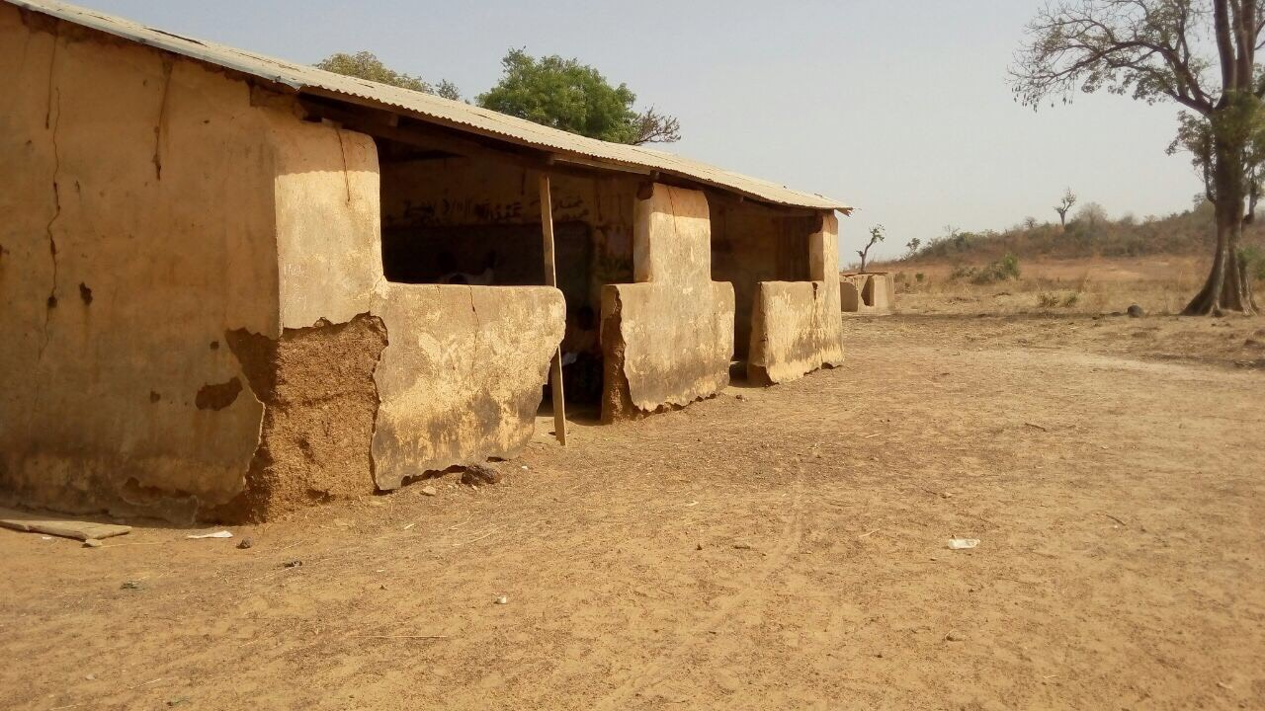

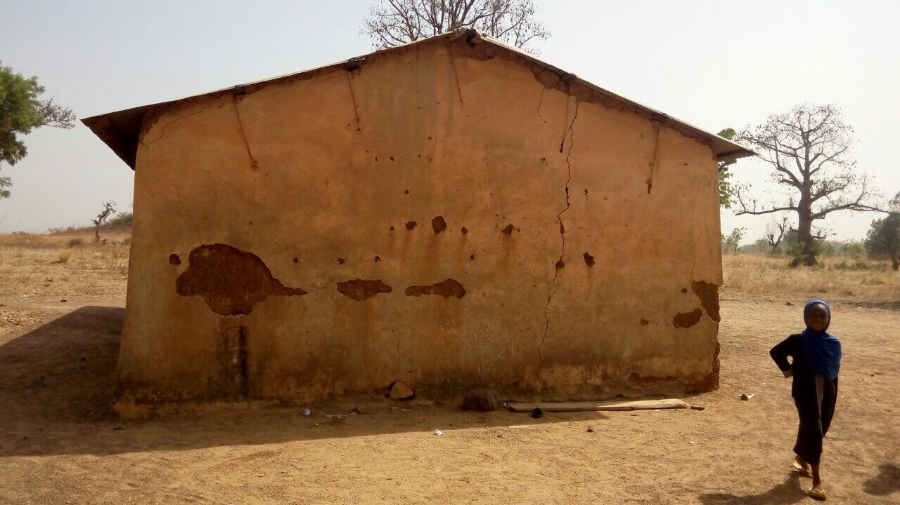

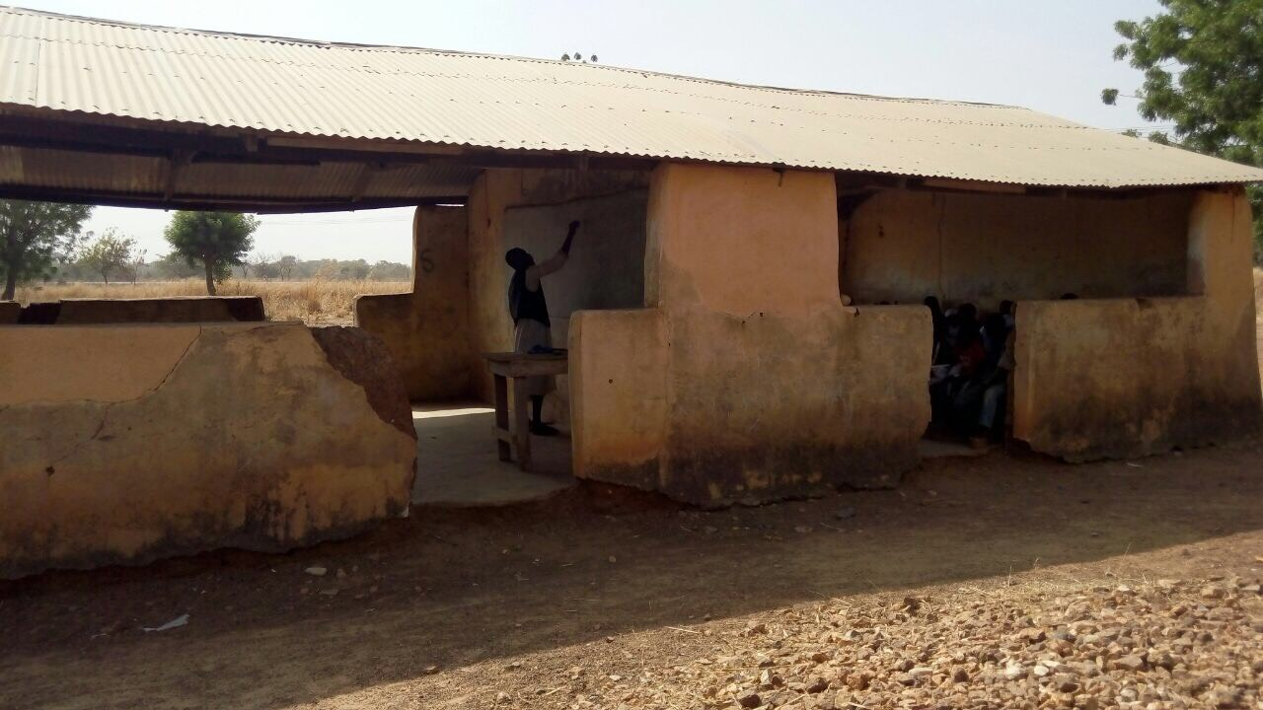

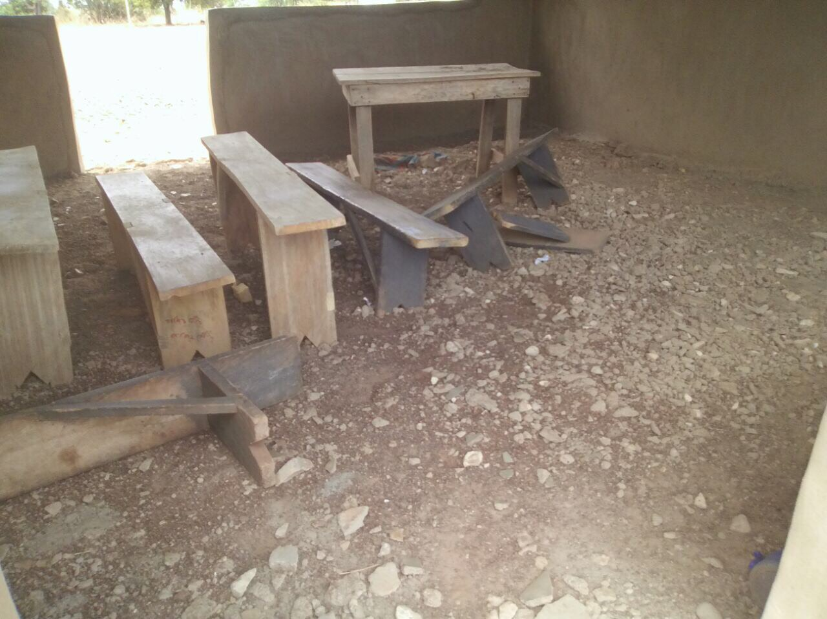

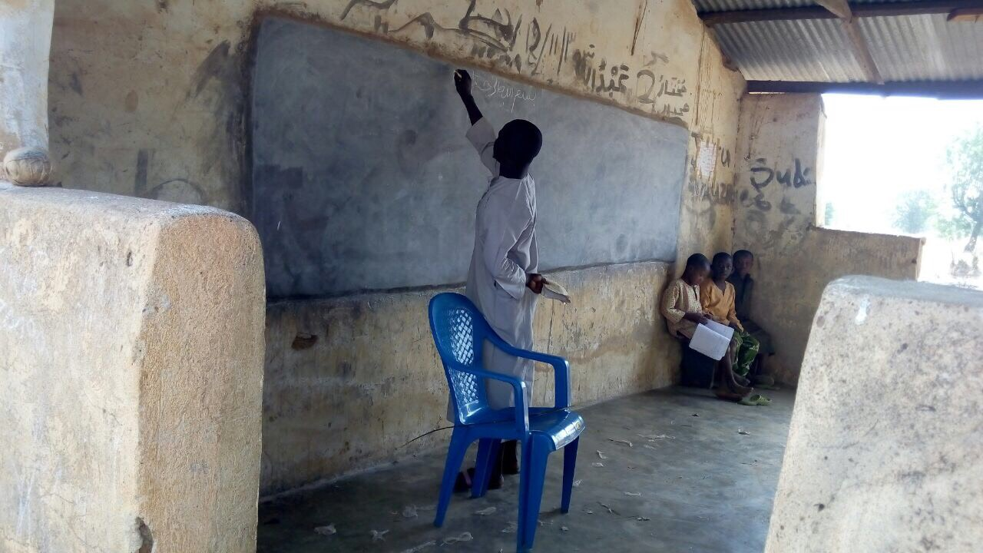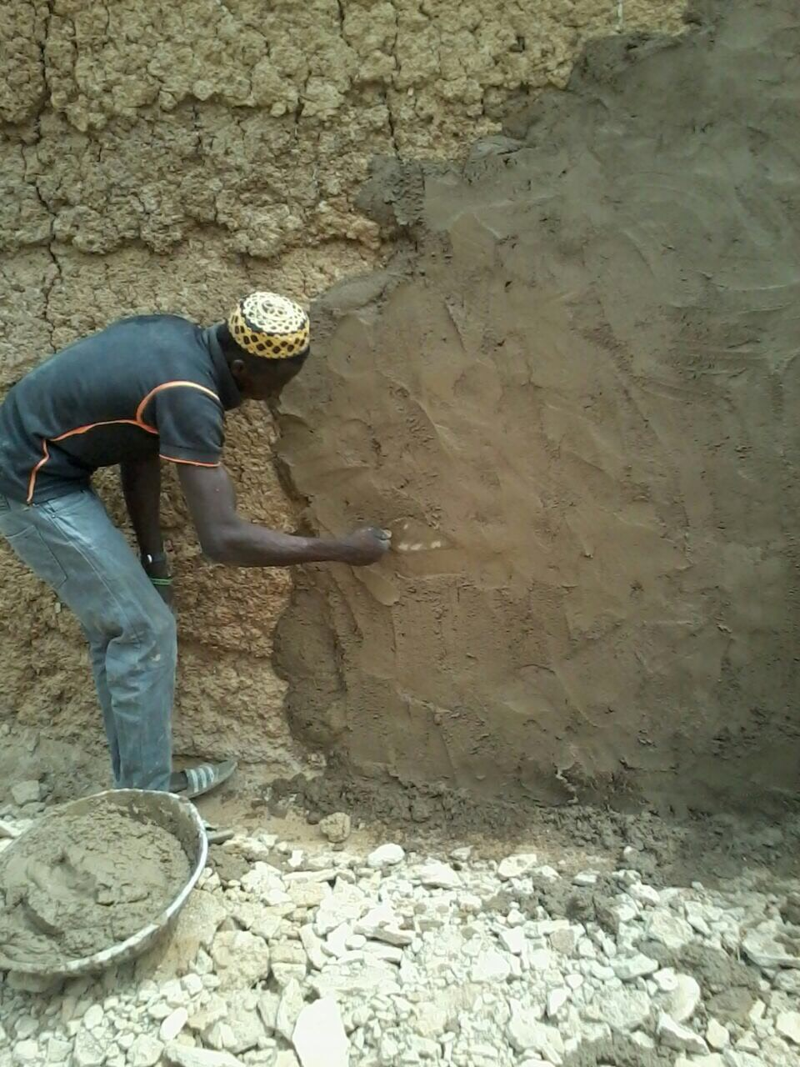

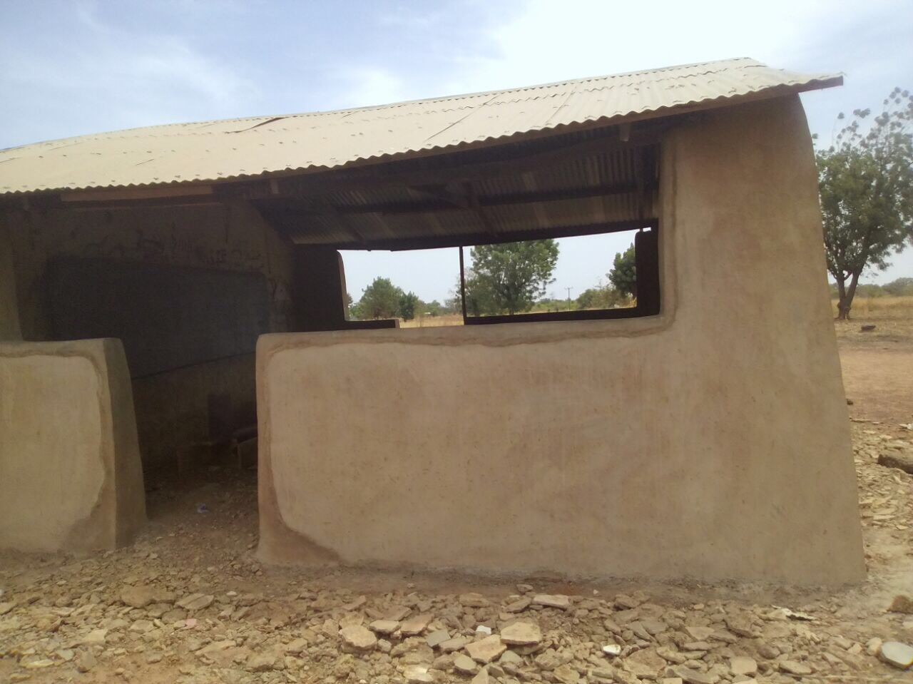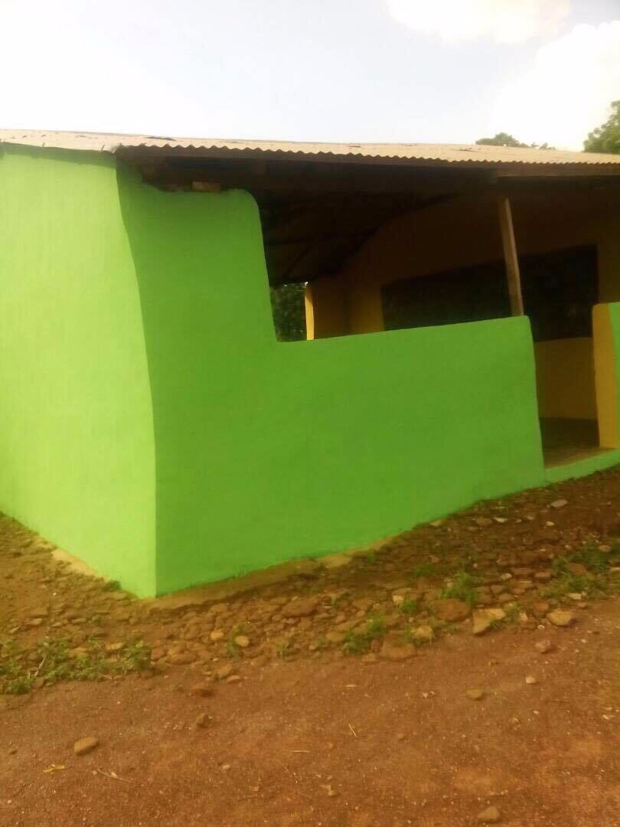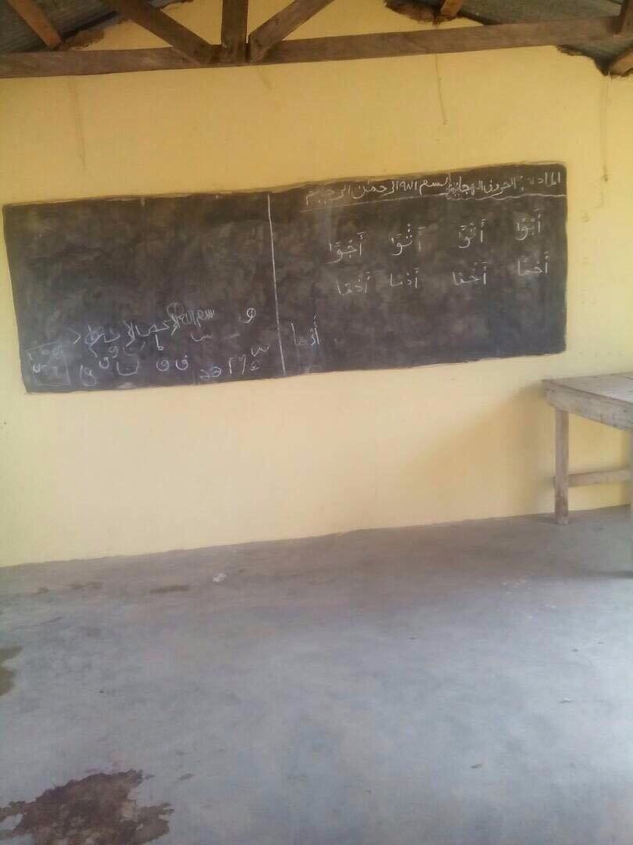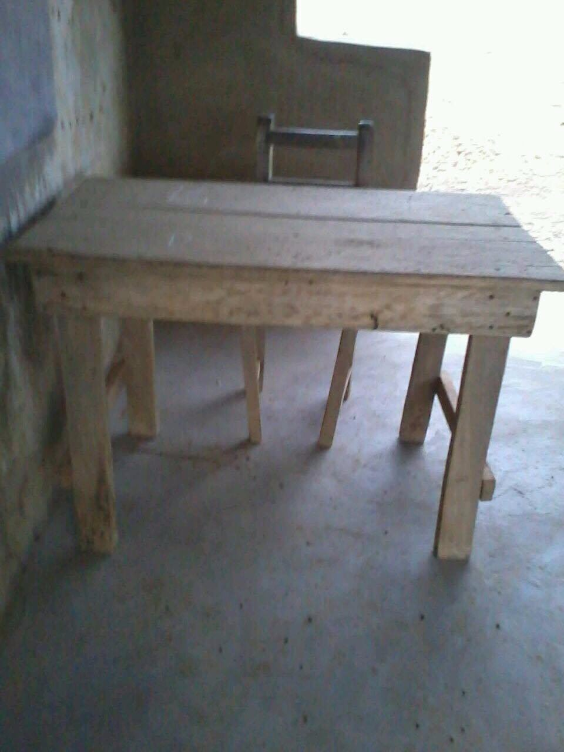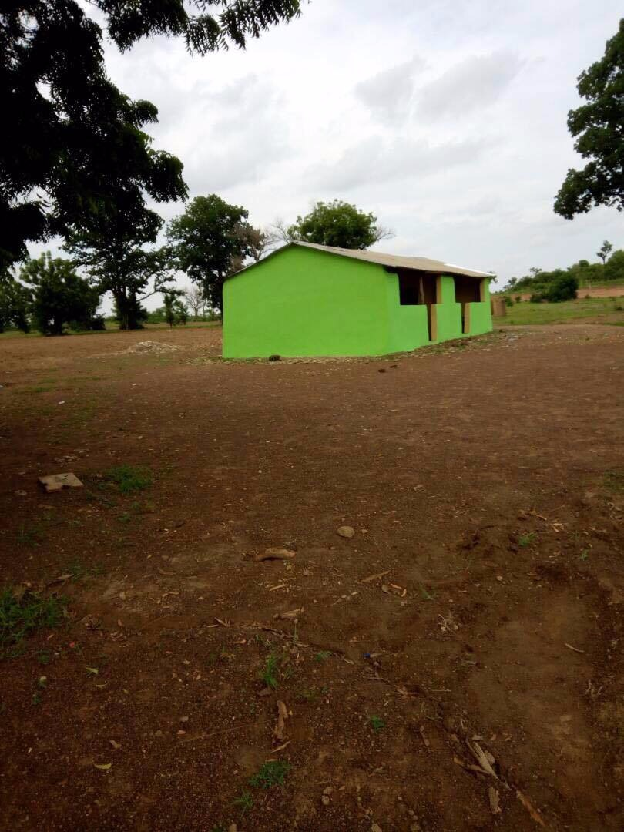

**2) High School :  
Location: Kampung Cham, Cambodia  
Total Expenses: $14,319.80**

- There was no high school in Kampung Cham, Cambodia. AMAL’s team took initiative in building a high school for the students in the village of Cham to help the students in persuading their studies of high school. The school was acknowledged by Mufti of Cambodia and all the expenses were covered by AMAL. The whole development the school was monitored by AMAL’s team in Cambodia.   
The pictures of the school building process: Process-After  
  
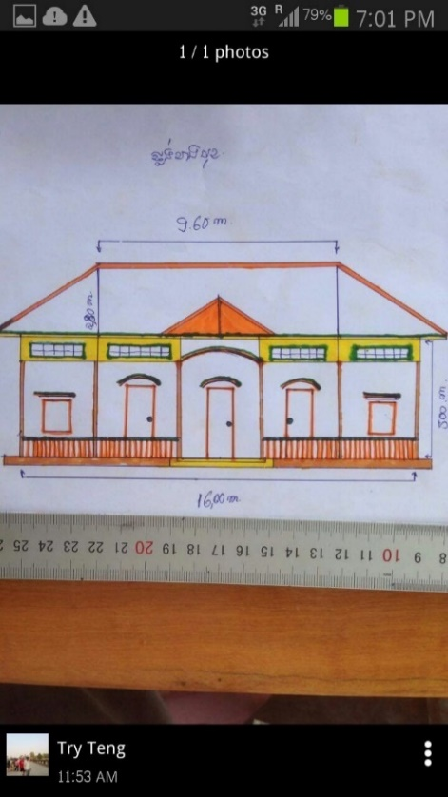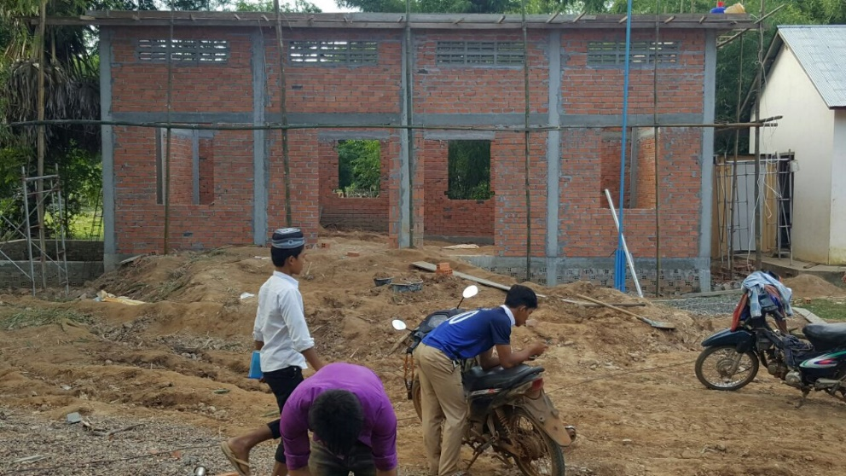

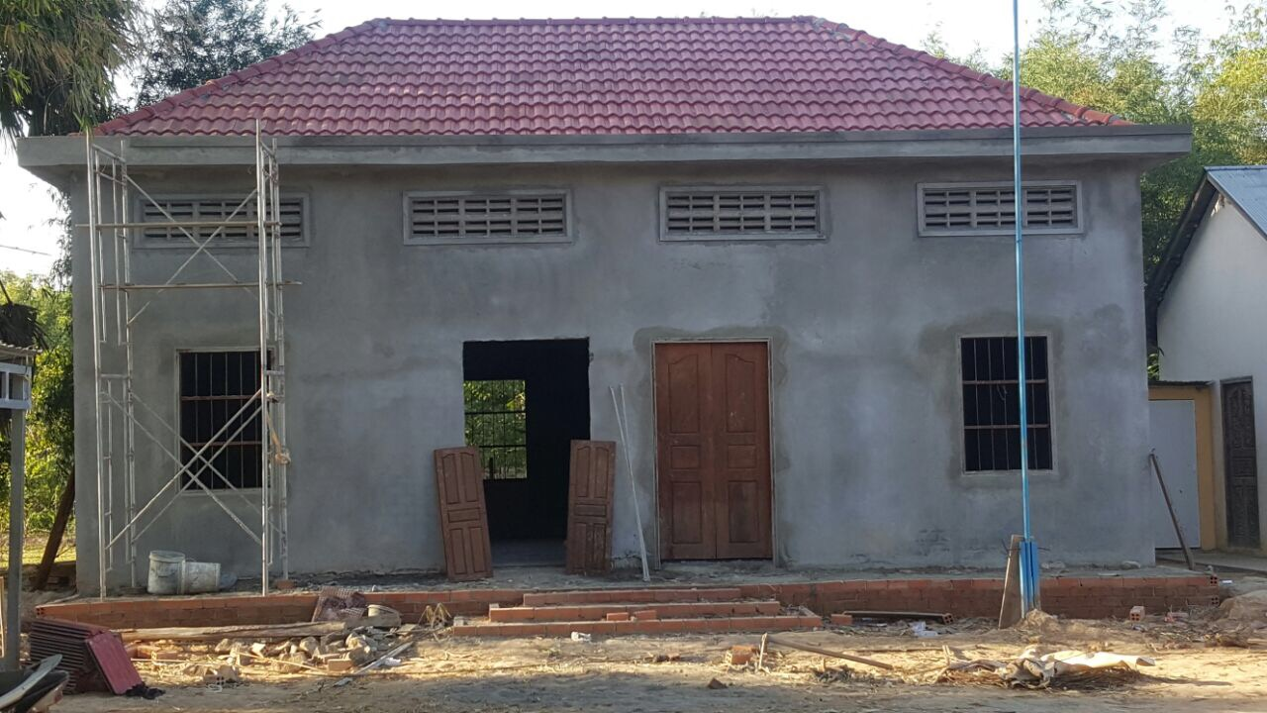

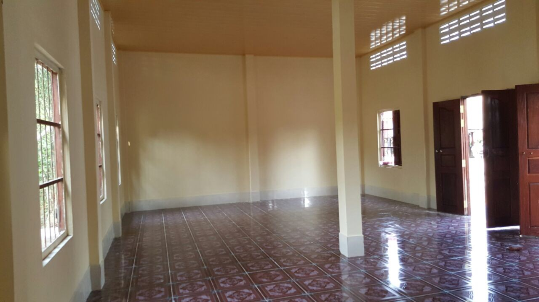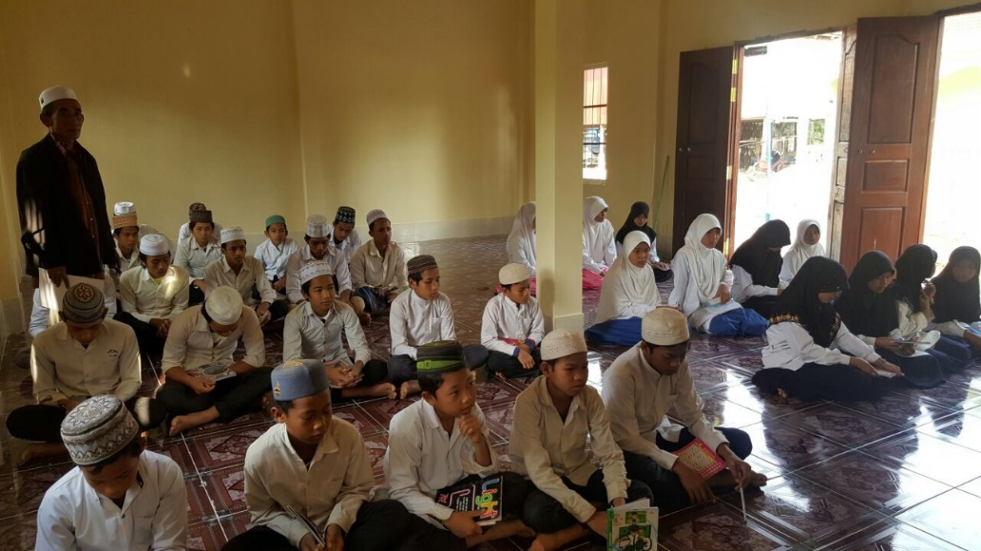

**ii) 8 Water Wells   
Location: Kampung Cham, Cambodia  
Total expenses= $358/well  
-** The villagers had no access to clean water neither at homes, nor in an area nearby. There were 8 water wells built by AMAL’s team and they are in use now. The water wells expenses were completely covered by AMAL’s team.

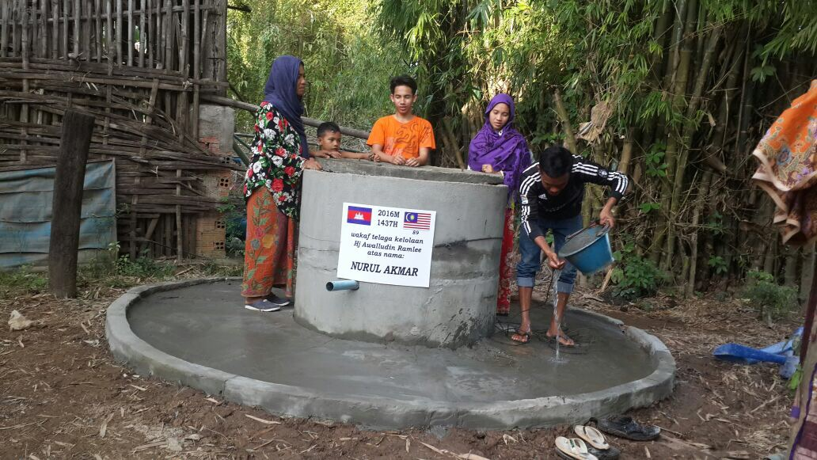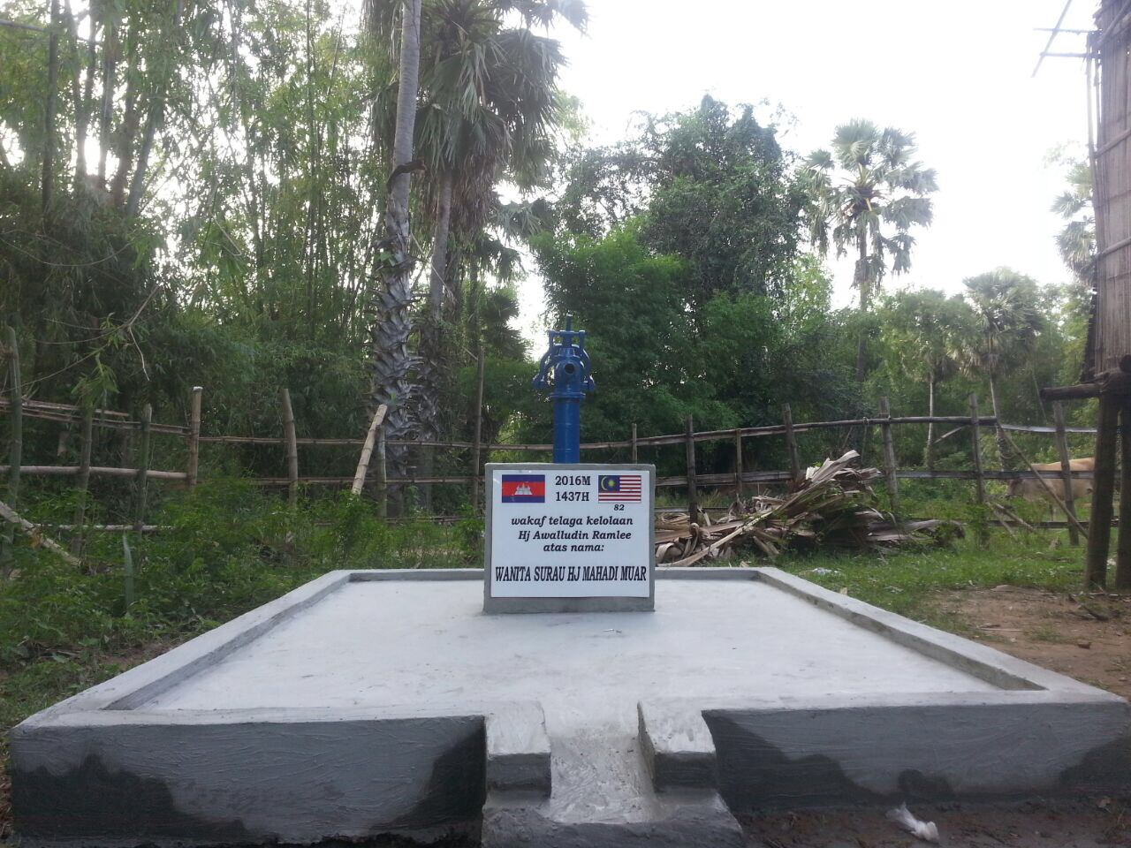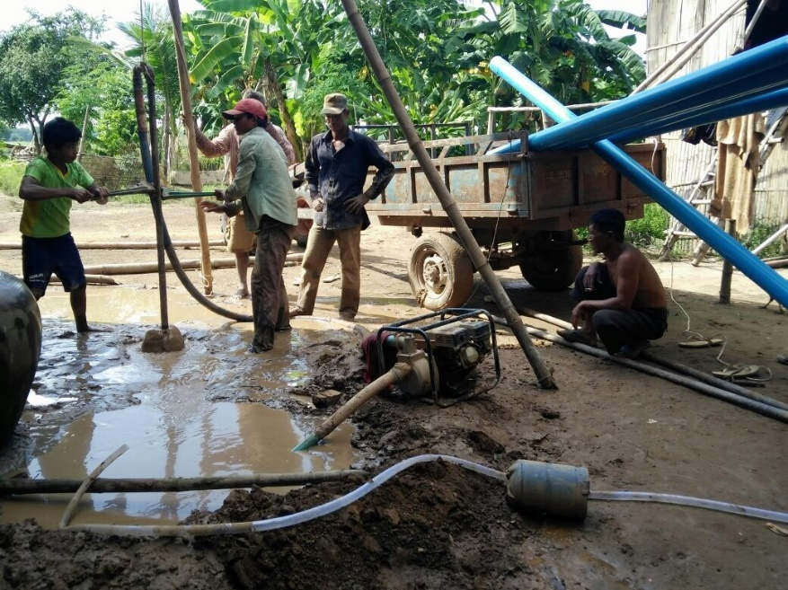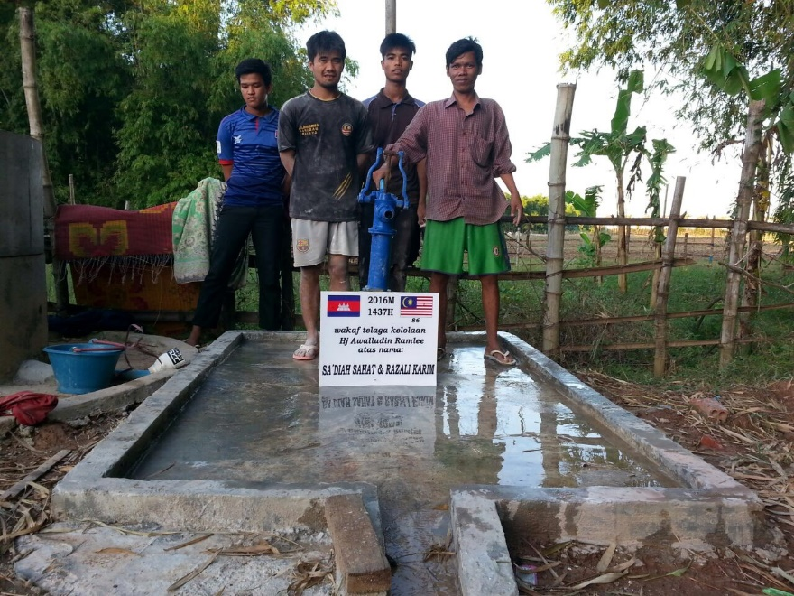

**iii) Massjed Renovations:  
Location: Kampung Cham, Cambodia  
Total Expenses: $439   
-** The mosque of the same village needed some necessities for example praying carpets. All of the necessities provided for the Mosque were beneficial and needed by the Muslim villagers in that area. Moreover, the electricity supply in the mosque was poor, hence we provided solar panels to run the electricity of the mosque smoothly and there won’t be problems faced on the long-run.  
The photos are provided:

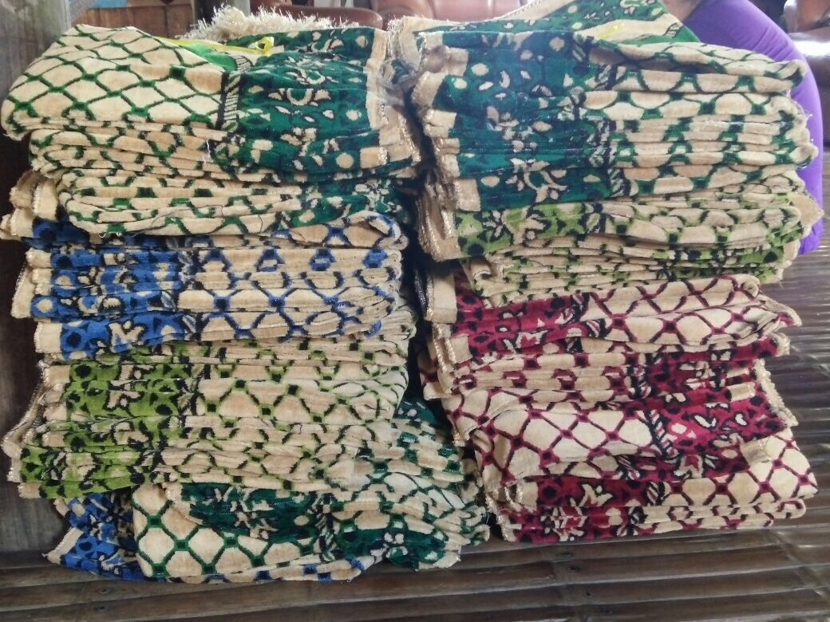

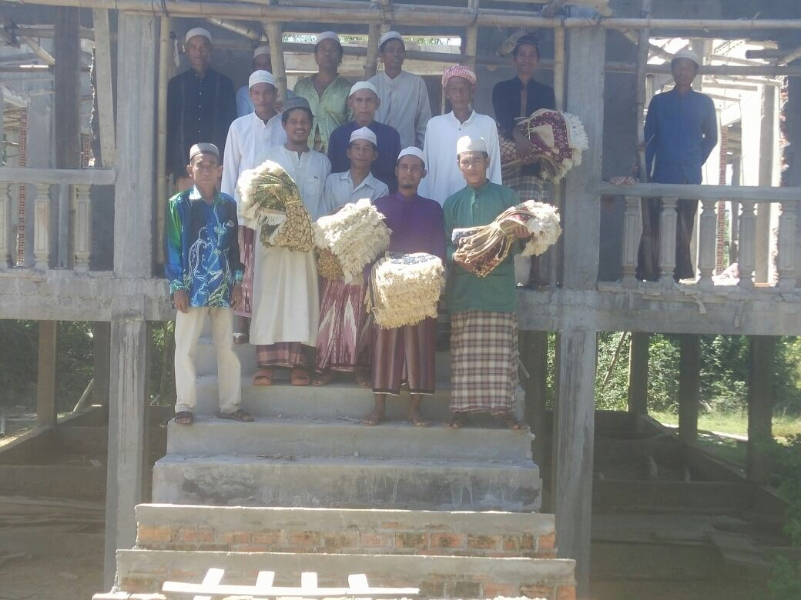

**New Projects:**

There are several agendas that Civi.Amal is conducting, the programs on the agenda will be listed below with explanations. The following programs will help in several countries where we have our own teams. The countries Civi.Amal can provide support and help for are some of the Asian countries such as Cambodia, Indonesia, Malaysia, Thailand, Vietnam, Laos, Syria, Plantain, Pakistan, Bangladesh, India, Philippines, Myanmar, Sri Lanka, Maldives, Iraq, Saudi Arabia, and Yemen, the African countries Civi.Amal can support are Egypt, Sudan, Uganda, Tanzania, Nigeria, Cameroon, Eritrea, Somalia, Morocco, South Africa, Chad, Libya, South Sudan and Ghana. The list of the countries still expanding. Civi.Amal has its own platform to collect donations and calculate the amount needed for any of the projects mentioned below as there will be currency and prices difference from time to time.

These programs are meant to be held in the rural areas, to those who are really in need of help and are willing to accept it. For the donations collection the amounts can be from $1 and there will be no limit and you can donate once, monthly, or even yearly. Moreover, you can follow up with what happens with your donation through email, website, or through our Facebook page.

The programs that Civi.Amal have been conducting:-

|  |  |
| --- | --- |
| 1) | Water Wells |
| 2) | Monthly Income |
| 3) | Small Businesses |
| 4) | Students’ Sponsorship |
| 5) | Food Supply |
| 6) | Teachers |
| 7) | Building Schools (Islamic and Non-Islamic) |
| 8) | Humanitarian/ or Humane Cases |

**1) Water wells:-**

Who will use it if there’s mineral water everywhere?

Why would you donate?

* These questions have answers and you may get surprised because in some areas in a lot of countries around the world, people don’t know what the meaning of mineral water is or even clean water because they cannot get access to it. Parents send their children at least 5 km away to get a gallon of water every day instead of going to school or playing. Clean water is a blessing and many are suffering to get clean water.

If you are willing to help others in getting clean water as normal people, please don’t hesitate to donate with any amount **“here”**.

**2) Monthly Income:-**

An income to a family is one of the basics of life that no one will be able to have a different point of view about. Some families either lose their jobs because of the war, high rate of inflation in their countries or because they are new refugees. No income means a family can’t afford the basic necessities of life, such as shelter, clothes, or food.

If you are willing to sponsor a family for their monthly income or donate some amount of money for them, please click **“here”**.

**3) Small Businesses:-**

How should I support my family without asking people for money, while I’m in need?

* Small businesses are meant to support families not only a single family. Many people don’t like accepting any type of help except if they work for it or they pay in return, Civi.Amal team came up with the idea of supporting groups of families which can work by starting-up a small shop for them. As a result, they will work and gain their own income to support their families’ and there will be many opportunities of work for several members from each family.

If you are willing to donate for monthly income for a family even if it is once, you may donate **“here”.**

**4) Students’ Sponsorship:-**

Why can’t I proceed with my undergraduate studies??

* Education is a right that each human being have to get. It is always a dream for school kids to be a doctor or an engineer. Luck and environment are not always in everyone’s favour. Some students are willing and dreaming of studying but their families’ can’t afford the expenses. Here comes the role of this program, where you can sponsor a student to proceed with his/or her studies. Moreover, this will help in building and shaping the future in a better way.

If you are willing to build someone’s future with any amount then go ahead **“here”**.

**5) Food Supply:-**

What happens when there is no proper food supply for people?

* The spotlight will be on the African countries’ that have people who suffer from extreme poverty and hunger that causes death. No water nor food at all, for days and maybe weeks. Obviously, people will die and they won’t have proper immune systems. Hence, many diseases will spread such as Malaria that directly end their lives’. Our aim is all these people that have the right to live like the rest of us.Civi.Amal is also supporting people who are below the poverty line in any country the eams can reach.

If you are willing to donate to provide constant food supply for people, click **“here”**.

Families’ Support After a loss:

* Moreover, the loss of infants because of hunger and weak nutrition system isn’t really different from losing an adult. There is a team of experts that provides physical and emotional support that will be able to help and make them feel better to be able to cope up with their lives.

Don’t hesitate to donate to help in saving families instantly, **“here”**.

**6) Building Schools and Sending Teachers:-**

What did you start at the age of five?

-Normally, at the age of five children are sent to school to start their studies journey that will take almost 14 years of their lives. Education is an essential part of our lives.However, there are some areas that are undeveloped and have no schools, other areas have schools but they have no teachers. To build a better civilised community, Civi.Amal did built schools in some rural areas that have no schools and sent teachers as volunteers to teach children and teenagers the basics of knowledge they must have, but we still need continuous monetary support

If you are willing to be part in building a school, please click “here”.

Islamic classes

- Islamic classes is a project that aims for building classes that will teach Quran and Hadith, which will help the students in the recitation and understanding of their religion holy book, Quran, and their Prophet Muhammad (S.A.W) sayings, Hadith, the classes won’t be only for children but for adults too.

If you are willing to donate and support this type of project, please click **“here”**.

Moreover, If you would love to start your own charitable project, you may contact us. We will be able to support you with whatever needed to accomplish the project.

**7) Humanitarian Cases:-**

**-** Some people have a normal life or a life that is exactly on the poverty line. At any moment, their life might go under the line and they will be need help. Some cases, are undefinable unlike all the cases that was mentioned earlier, here is a glimpse about it.

* Humanitarian means loving others and doing good. Under this particular support, Civi.Amal helps cases such as:
* Anyone that needs their medications, especially the ones who can’t really afford them on long-term basis.
* A family member went into the hospital for an emergency operation and his/or her family can’t support it
* Families’ that have a disabled child/ or adult and the mother and father can’t support the disability needs anymore.
* People who doesn’t have necessary items at their houses, such as fridge, air conditioner, stable electricity supply, lamps, washing machine etc.

The discretion of the cases that we are supporting currently is listed below:

(to be added later)

Don’t hesitate to contact us for further questions or if you would like to donate directly for any of the projects. Please click **“here”.**

**UN Projects:**

|  |  |
| --- | --- |
| 1) | Providing water supply. |
| 2) | Providing food supply including doctors’ checkup. |
| 3) | Sponsoring students to proceed their education. |
| 4) | Providing a family necessities’. |
| 5) | Providing shelter. |

**Note: The prices given are calculated by the United Nations High Commissioner for Refugees (UNHCR)**

1. Water Supply

* Clean water is one the most important basic necessities to live a normal life. It helps bodies’ to fight infection, reduce the risk of cancer, keeps the heart healthy etc. Refugees around the world needs a clean water supply, to help more than 2.5 million refugees to get clean water supply the donation needed is as follows:-
* Water supply for two months= $35.
* Water supply for 6 months= $105.
* Water supply for one whole year= $201.

1. Food Supply

* Food is something everyone consumes in their daily life. No one might think that food would never be there tomorrow or even after one hour because food supply is everywhere around us. In the upcoming July, there might be around 5.5 million people starving to death out of hunger around the world mostly in Sudan, Yemen, Nigeria, Somalia etc. The cost of saving people from starving is as follows:
* Food supply for 2 people per year= $100.
* Food supply for 20 people who are in emergency cases’= $600.
* Moreover, the food supply the families have is not clean and it may cause harm especially on kids. It may cause Diarrhea and Pneumonia. There are many doctors that can check up on these kids and provide them the medications needed. The cost of doctors’ consultation is as follows:
* Consultation for 5 children= $50.

1. Education

* In fact education is a human right for every person living on this earth. Only education can help communities to fight diseases, hunger, unethical manners such as robbery. There is more than 1 million children that are refugees and 425,000 from them are below 5 years. Children don’t deserve to be deprived from their right to be educated. Sponsoring students is possible and the cost is as follows:
* Sponsoring a child in an elementary school per month= $50.
* Sponsoring a child in an elementary school per year= $450.
* Sponsoring a student in the secondary school per month=$80.

1. Family Necessities’

* Girls normal marriage age is 18-19 years old onwards that is because she is categorised as a young adult, as she can handle the responsibility of marriage. However, girls get married while they are 12 years old .
* The above scenario does happen in the refugees camp, girls who are 12 and above gets married, hence the family can get some money in return to buy whatever they need to live suitably. You can help families and rescue many girls from getting married while they are underage. The cost of providing necessities to families who are in need is as follows:
* Necessities for a family per month= $125.
* Necessities for a family per 6 months= $500.
* Necessities for a family per year= $1500.

1. Shelters

* Living in a safe country and roads, between 4 walls which is your current house and shelter is way more precious than you think. Your life will not be normal if there is bombing in the neighbourhoods. By 2018, there will be around 2 million people who left their countries’ as it isn’t a safe place to live in. These people will be living without shelter nor tents, moreover those who have shelters their shelters’ will need to be fixed. The cost of providing and fixing shelters is as follows:
* Shelter for a month= $125.
* Shelter for 6 months= $750.
* Shelter for a year= $1500.

**CONTACT US:-**

**If you have any questions regarding the projects that we are conducting, Please don’t hesitate to contact us on:**

**Facebook:**

**Instagram:**

**Twitter:**

**Email:**

**Phone:**

**(To be created and added later)**